上海越都 大幅面入口碎纸机
YD-GD800机型 条状效果
Shanghai YUEDU | Large Format Paper Shredder
Model: YD-GD800B | Produces strip-cut effect

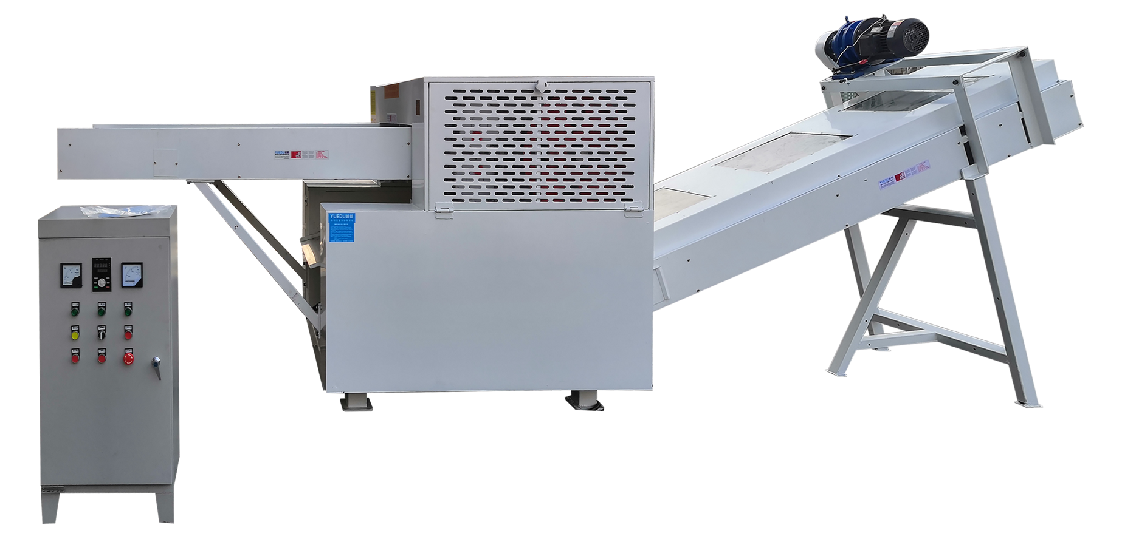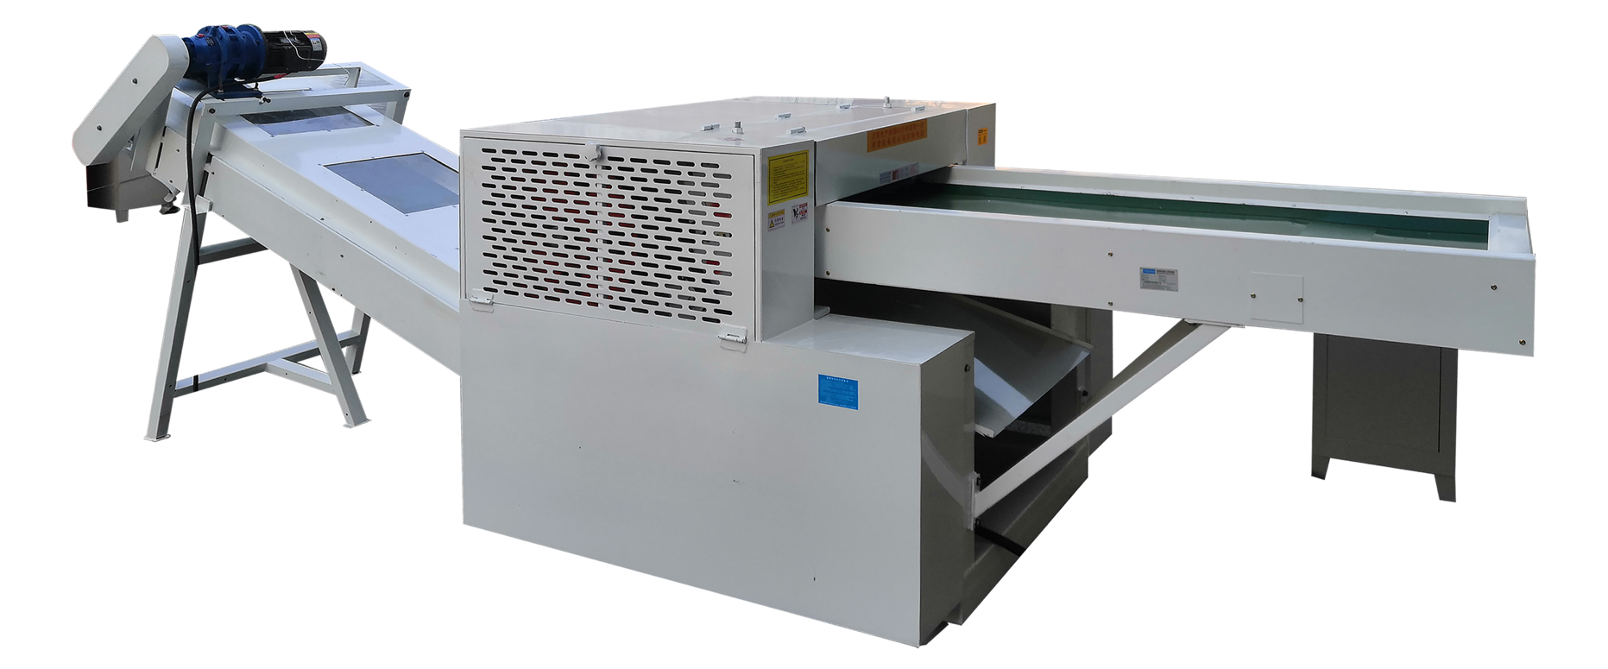
（800入口设备参考图：不含出料输送带）

Main Product Specifications Table
产品主要参数表
 | English | 简体中文
Equipment Parameters:  设备参数 | - Blade Length: 800mm  - Shredded Strip Width: 5 - 30mm (adjustable)  - Effective Width of Feed Inlet: 720mm  - Cutting Thickness: Within 5-8cm  - Matching Power: 23KW  - Input Conveyor: 3000*720mm  - Output Conveyor: 3000*720mm  - Control: Electric Control Box | 刀具的长度 800mm  粉碎条状的宽度 5 - 30mm（可调整）  进料口有效宽度 720mm  剪切厚度 5-8cm以内  配套动力 23KW  输入带 3000*720mm  输出带 3000*720mm  电箱 电箱控制
Pricing  价格 | Pricing RMB: RMB 177510  Pricing USD: 25359 | 不含税含运价格 157089元  含税含运价格 177510元
User Site Case Study Video 1  用户现场案例视频1 | Secure Document Disposal Made Affordable: Yuedu GD Series Book Shredder Solution书本粉碎机设备https://youtube.com/shorts/u4YYAzKWnjE | 【烟包二维码粉碎方案（第2集）：中烟工业福建厦门某卷烟厂。粉碎烟盒外包装纸张 和 烟盒上的二维码，破坏防伪码避免外泄。#二维码粉碎机 #二维码碎纸机 烟包碎纸机-哔哩哔哩】 https://b23.tv/D4hHk2w
User Site Case Study Video 2  用户现场案例视频2 | 便宜的保密销毁中心设备方案：废品回收站（资源回收公司）帮助客户解决保密文件销毁的难题，采用越都品牌gd系列书本粉碎机进行保密销毁工作，输送带进料和出料，整本书直接粉碎，入口宽度80cm https://youtube.com/shorts/mdwfXZ2o6l0 | 【包装印刷厂卷烟厂产品包装二维码粉碎方案（第三集）：中烟工业云南昆明卷烟厂 红河 彩印包装厂，粉碎烟包上的二维码图案。#包装印刷厂碎纸机 #彩印包装厂粉碎机-哔哩哔哩】 https://b23.tv/aQ4ADPm

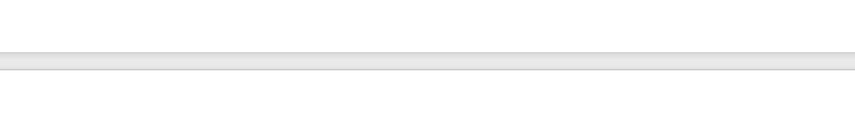

YD-GD800B
Belt Conveyor Shredder
越都 YD-GD800B碎纸机

皮带输送带碎纸机 销毁中心

The blades are wear-resistant and have a long service life, making them suitable for shredding various sensitive materials. This shredder has good stability, impact resistance, and vibration resistance, ensuring safe operation under long-term heavy loads. Shredding Effect: Customized output in strip or chip form according to customer requirements. Discharge Method: Can be connected to an external discharge conveyor or central suction duct. Can shred: Wood cellulose, paper, film, cardboard, etc.
刀具耐磨、使用寿命长，适合多种涉密介质的粉碎；该碎纸机具有良好的稳定性、抗冲击性、振动性，确保设备在长时间重负荷中安全运行。粉碎效果：根据客户要求，定制出料条状或者出料片状（如上图）。出料方式：可外接出料输送线或中央吸风管道。可碎：木质纤维素,纸张,菲林,纸箱,等。

Effects of Different Materials
(Strip and Chunk)
各类材料效果（条状 和 块状）

Strip: Adhesive  条状：不干胶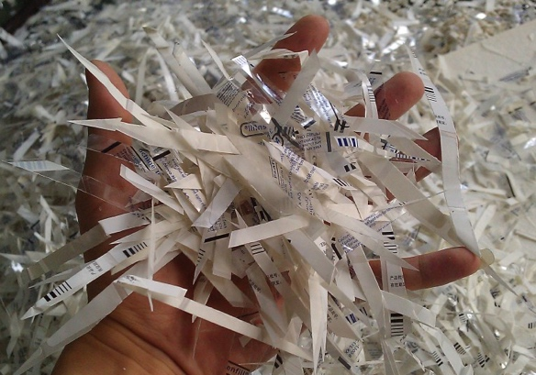 | Strip: Wood fiber board  条状：木质纤维板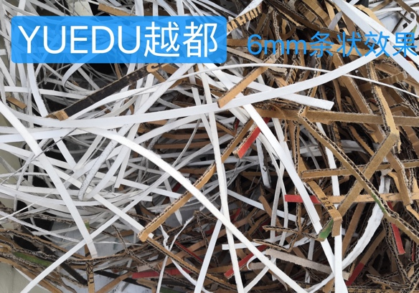 | Strip: Paper  条状：纸张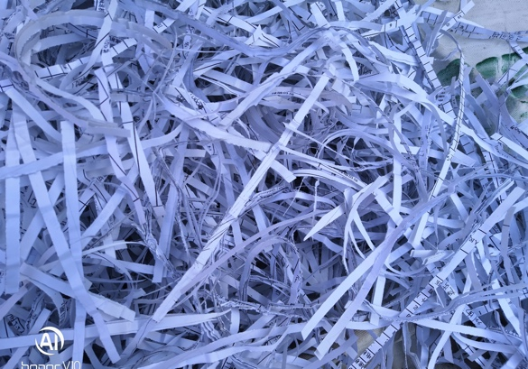
Block: Fabric fiber  片状：布料纤维  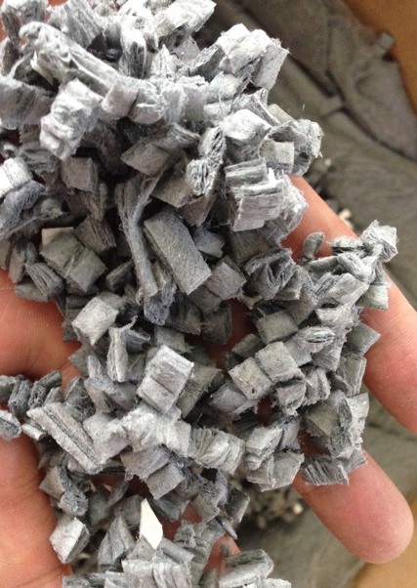 | Block: Wood fiber  片状：木质纤维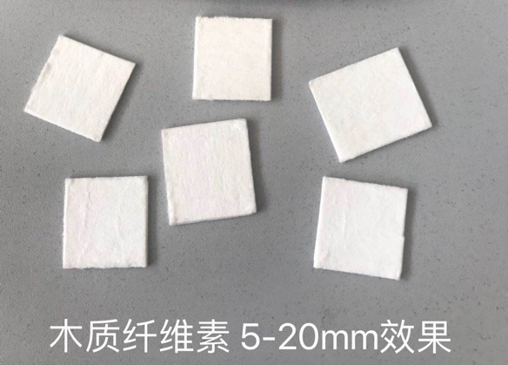 | Block: Wood fiber 2  片状：木质纤维2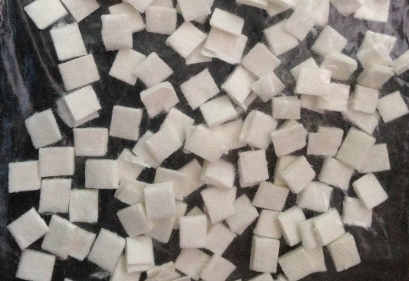
Note: The machine defaults to strip shredding. If block shredding is required, please contact customer service to specify customized requirements (additional charges apply).
注明：机器默认为粉碎条状，如需块状效果，请联系客服说明定制需求（额外收费）

Very Powerful, with an 800mm Wide Inlet

强得很 入口宽达800mm

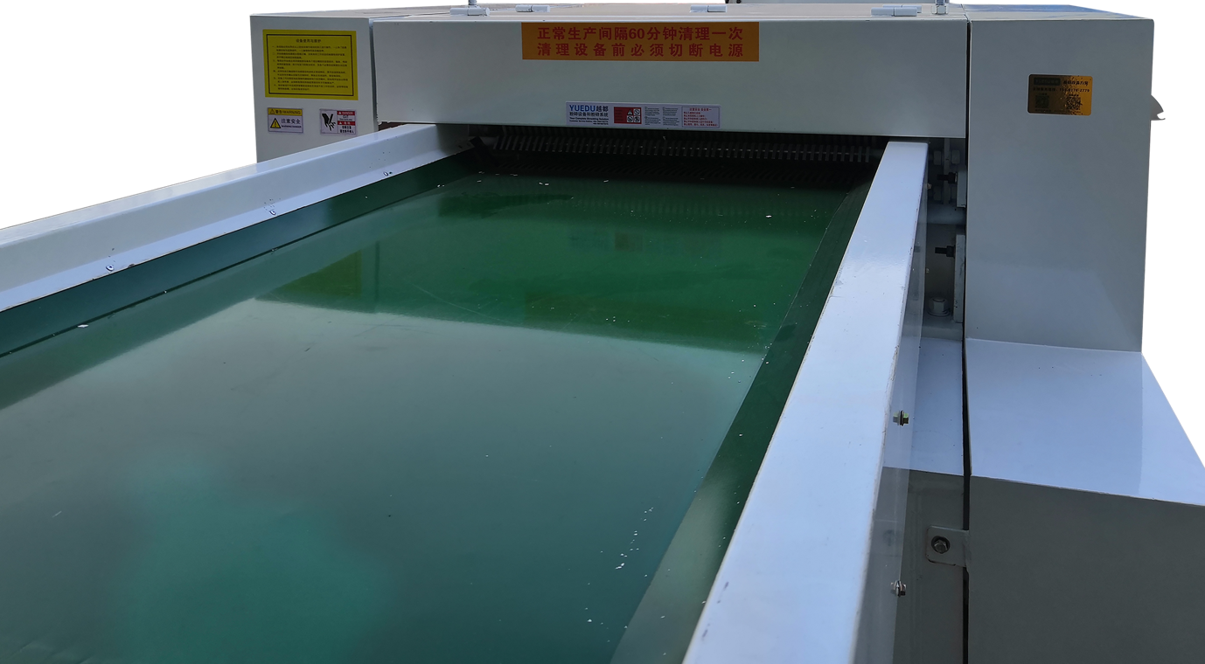
🍭 The entrance width can be widened to 1.2 meters. For details, please inquire with our customer service staff.
入口宽度 可加宽至1.2米，详询客服人员

Equipment Details Diagram
设备详情图

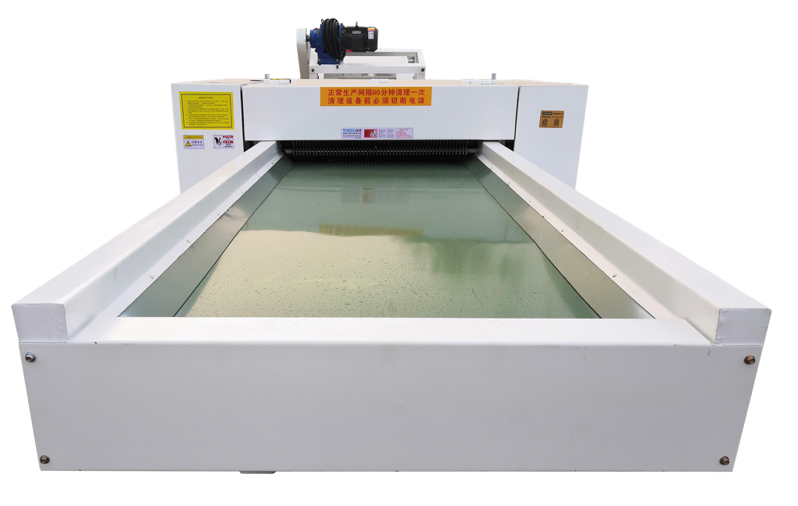 | 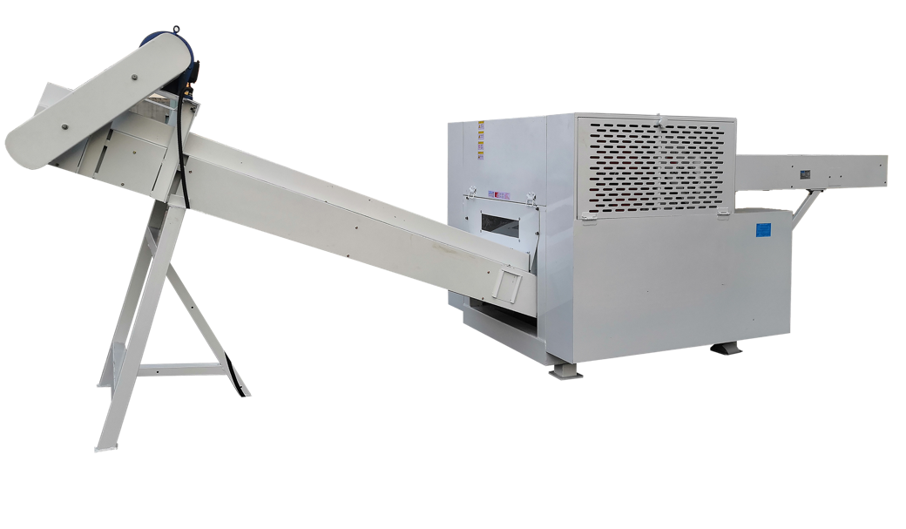
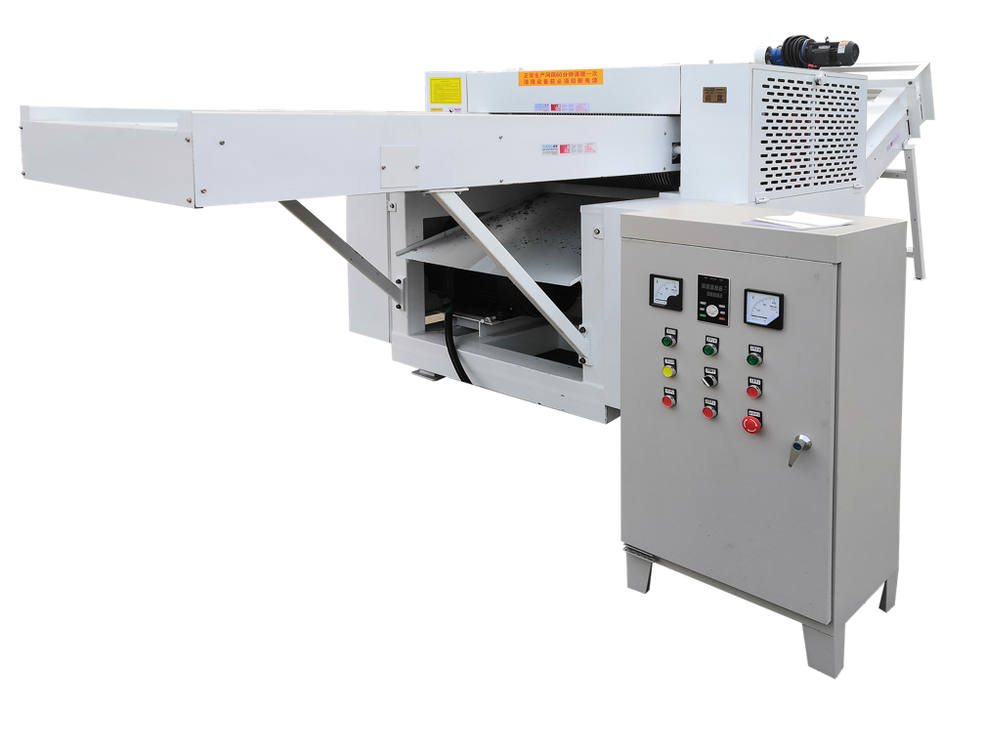 | 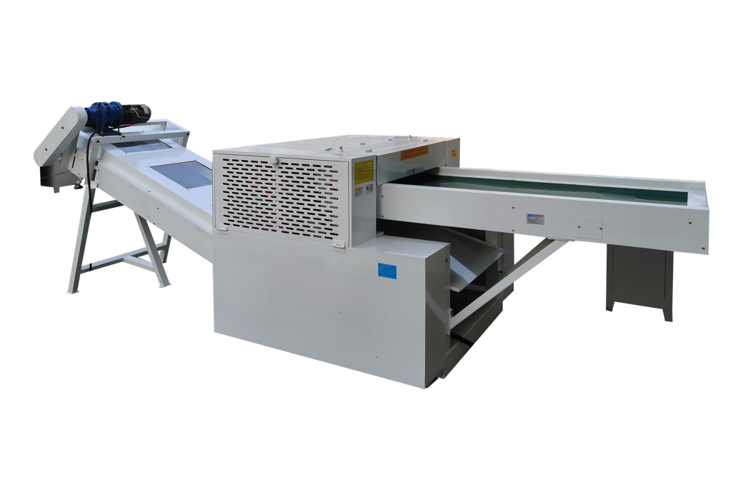
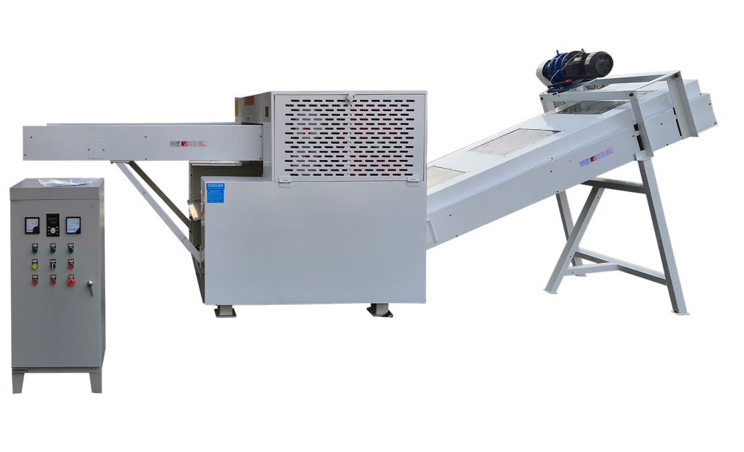 | 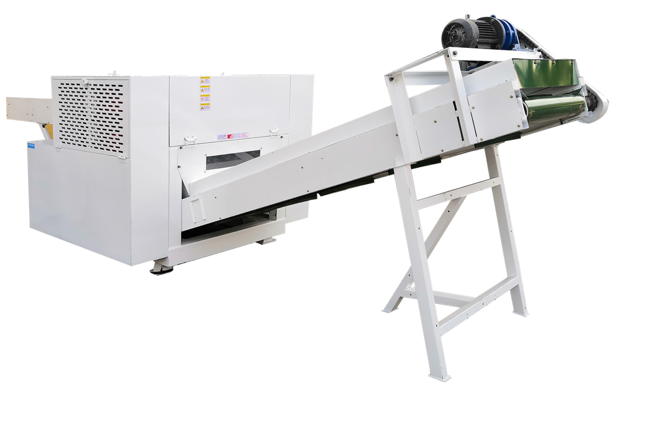

Installation Dimension Diagram (Three Views)
安装尺寸图（三视图）

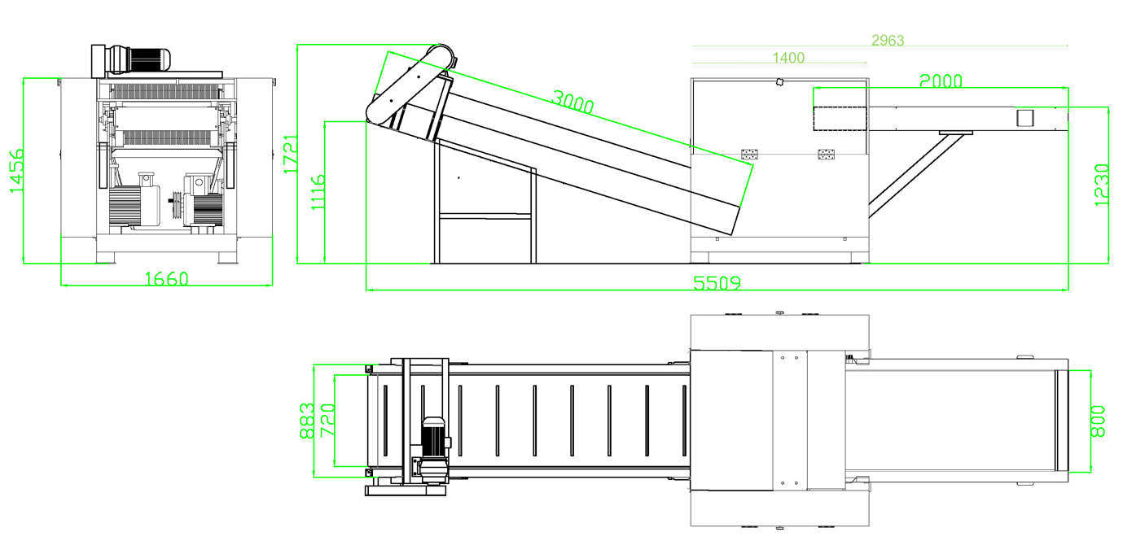
🍭 🍭The dimensions confirmed by both parties shall prevail when placing the order.
以下单时，双方确认尺寸为准

Case 2: 800mm Inlet Effect and Three Views

